# Section 3.8: Implicit Differentiation

If the relationship between the function $y$ and the variable $x$ is expressed by an equation where $y$ is not expressed entirely in terms of $x$, we say the equation defines $y$ implicitly in terms of $x$.

## Implicit Differentiation

Implicit differentiation allows us to find slopes of tangents to curves that are clearly not functions (they fail the vertical line test) and allows us to find the derivative of an implicitly defined function without ever solving the function explicitly.

**To perform implicit differentiation on an equation that defines a function $y$ implicitly in terms of a variable $x$** :

1. Take the derivative of both sides of the equation. Keep in mind that $y$ is a function of $x$. Use the chain rule to differentiate $y$ with respect to $x$.
2. Rewrite the equation so that all terms containing $\frac{dy}{dx}$ are on the left and all terms that do not contain $\frac{dy}{dx}$ are on the right.
3. Factor out $\frac{dy}{dx}$ on the left.
4. Solve for $\frac{dy}{dx}$ by dividing both sides of the equation by an appropriate algebraic expression.

Media: Watch these [video1](https://youtu.be/kroPpRJI0QM) and [video2](https://youtu.be/8VQVErQmOa0) examples on implicit differentiation.

Media: Watch this [video](https://youtu.be/5hjA_Ty_e3U) example on finding the second derivative with implicit differentiation.

Examples

1. Assuming that $y$ is defined implicitly by the equation $x^{3}\sin{y}+y=4x+3$, find $\frac{dy}{dx}$.
2. Find $\frac{d^{2}y}{dx^{2}}$ if $x^{2}+y^{2}=25$.

Media: Watch this [video](https://youtu.be/J8tOaG8-aB0) example on finding the tangent line with implicit differentiation.

1. Find the equation of the line tangent to the curve $x^{2}y^{2}+5xy=14$ at the point $(2,1)$.
2. Find the equation of the line tangent to the curve $y^{3}+x^{3}-3xy=0$ at the point $\left(\frac{3}{2},\frac{3}{2}\right)$. See figure below.

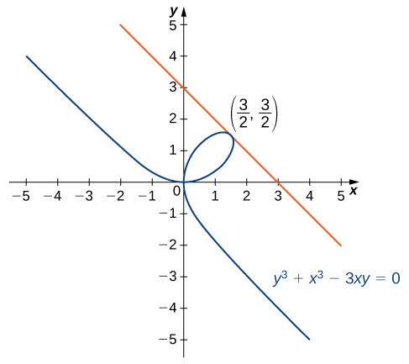

1. In a simple video game, a rocket travels in an elliptical orbit whose path is described by the equation $4x^{2}+25y^{2}=100$. The rocket can fire missiles along lines tangent to its path. The object of the game is to destroy an incoming asteroid traveling along the positive $x$-axis toward $(0,0)$. If the rocket fires a missile when it is located at $\left(3,\frac{8}{5}\right)$. Where will it intersect the $x$-axis?